### 2. Towards Uncertainty of CI Forecast (Pure CC Results)

Pick 3 locations.

* show CI prediction variance for different locations over 1 week. x-axis: date (same for all locations), y-axis: prediction accuracy
* show CI prediction variance for different time periods but one location. x-axis: date (four periods), y-axis: prediction accuracy
* (potentially): show CI prediction variance for hourly within a day. x-axis: hourly, y-axis: predicted vs actual (or prediction accuracy). (This isn’t completely solved with SPCI approach because we use a constant interval width)
* one to four-day prediction accuracy (avg?)

3 locations chosen

* CISO - California
* ERCOT - Texas
* ISNE - New England
* (SE, DE are Sweden / Germany - thought it’d be more consistent to keep it at regional level in the US)

GENERATED GRAPHS FOR SECTION 2

[Graphs for Section 2.ipynb](https://colab.research.google.com/drive/1gQgspiE9VFbzUq_PiliKb1SxiFxqqHzC#scrollTo=TwIIasVsLRWL) - in folder with the needed data here [section2_csvs_and_graphs](https://drive.google.com/drive/u/0/folders/1QsYEyyK1oA1xWvxtXhYlVnAvOVjNptOt)

**spatial uncertainty:** 3 locations over second half of 2022 (can extract a shorter timespan eg. week from here)

* note that the last column, accuracy, is per data point (=abs((actual-forecast)/actual))
* can add and average over per day if want to plot accuracy per day, instead of accuracy per hour
* direct + lifecycle both here
* based on pretrained models from CC repo (100 epochs) - look at first two tabs of each
  + [CISO](https://docs.google.com/spreadsheets/d/1mpgA3tr3FFkP71AMjAuAj32GnDb58WpNNFPaV-9KxYc/edit#gid=1394816240)
  + [ERCO](https://docs.google.com/spreadsheets/d/1fUoYhl5uz0_DNJYTG3-IEciHorMlVPCKAHRA1kl36EU/edit#gid=1512994353)
  + [ISNE](https://docs.google.com/spreadsheets/d/1RtgUiDcEIs5B08ypnTVsbV8flGQnRJlyfJ48mShw3kE/edit#gid=1817515157)
* 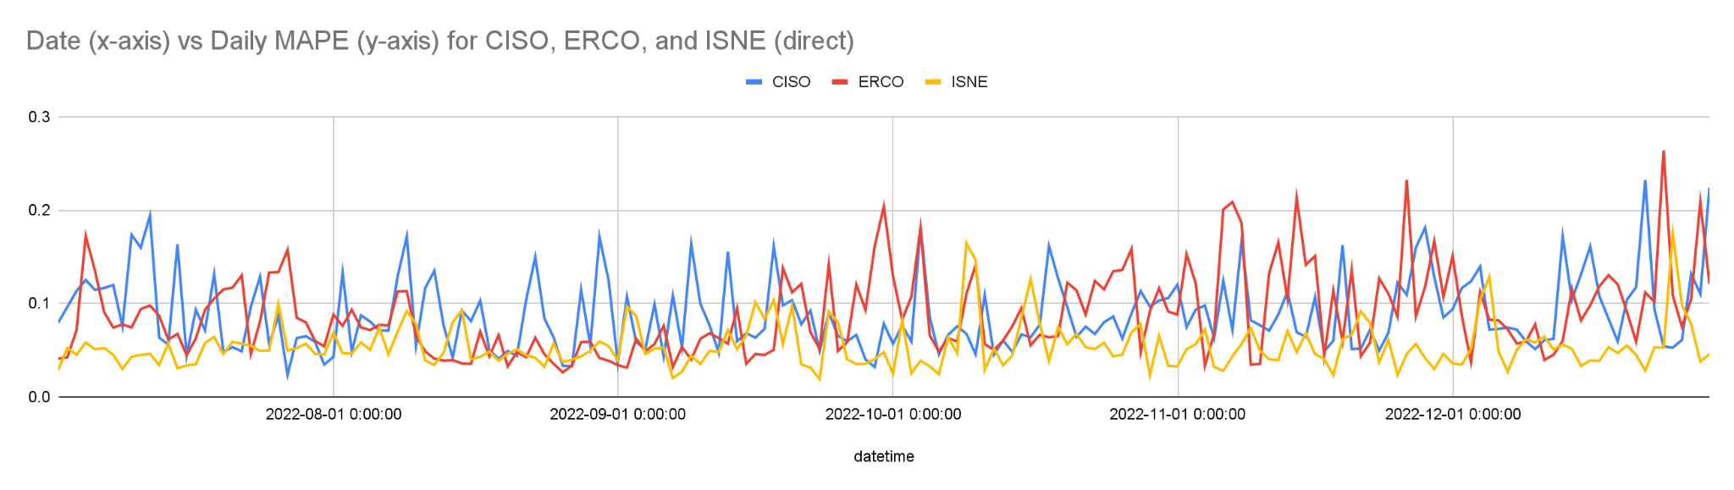
* 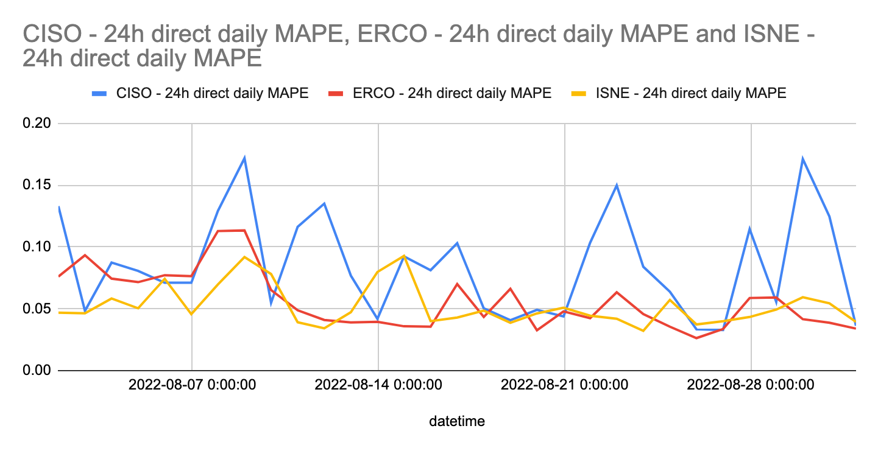
* we can take a subset of this so it’s better to look at^ plotted here - [CISO vs ERCO vs ISNE](https://docs.google.com/spreadsheets/d/1TlLBv7CuXGzDJeh7VhnGHBSpNWtAxclfr7SH4HpLafU/edit#gid=0)

**temporal uncertainty:** variance for different time periods but one location

* tried with CISO - [CISO](https://docs.google.com/spreadsheets/d/1mpgA3tr3FFkP71AMjAuAj32GnDb58WpNNFPaV-9KxYc/edit#gid=1844803559) **CISO direct - contrast 3 1 week periods**  tab
  + 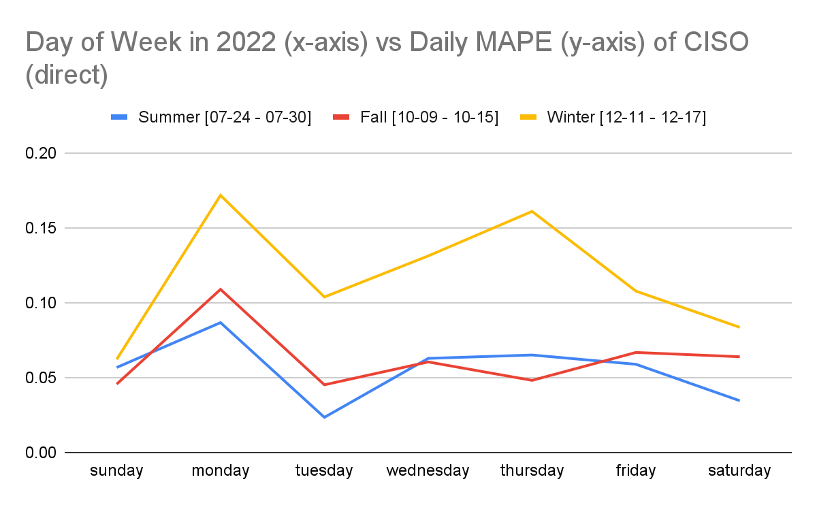
* can derive for any other areas if needed^

**long-term uncertainty:**

* [raw csvs](https://drive.google.com/drive/u/0/folders/1pkmN6kvWs5iJP2_830ZEYWh-AnM_pGhG) - raw CSVs for 96h predictions + per hour error are here (CISO, ERCO, ISNE, for direct + lifecycle) - just haven’t opened all as google sheets
* uploaded [CISO](https://docs.google.com/spreadsheets/d/1mpgA3tr3FFkP71AMjAuAj32GnDb58WpNNFPaV-9KxYc/edit#gid=1394816240)`**CISO_direct_96hr_CI_forecasts`** tab
* 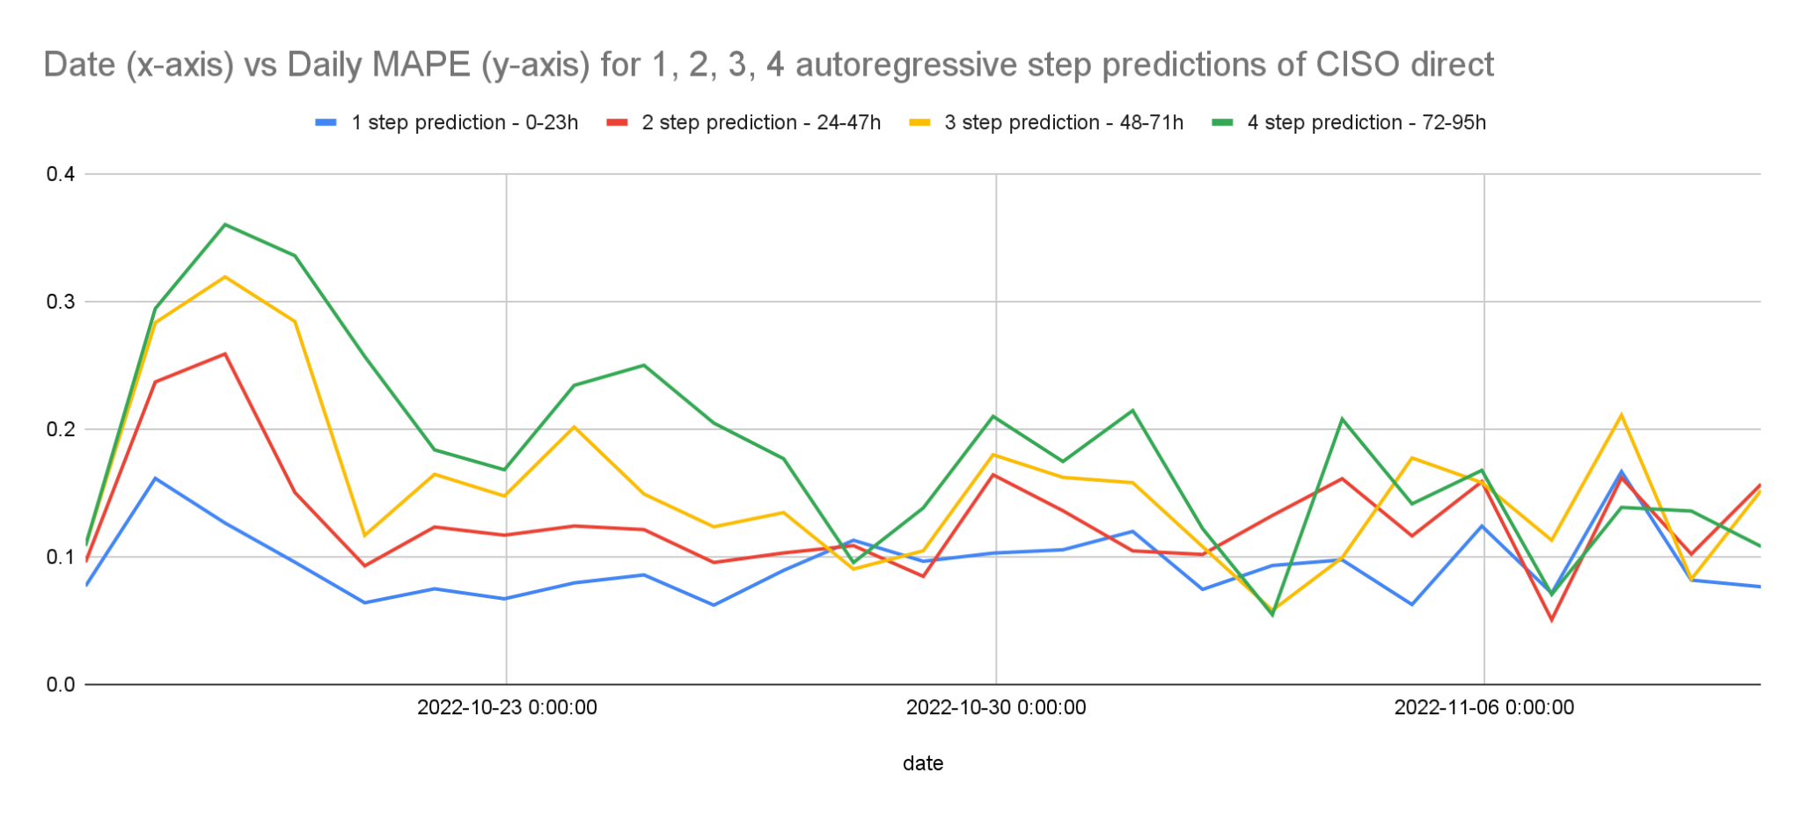
* can plot others - here’s one example^
  + look at [CISO](https://docs.google.com/spreadsheets/d/1mpgA3tr3FFkP71AMjAuAj32GnDb58WpNNFPaV-9KxYc/edit#gid=2112108709) **CISO direct - PLOT contrast 1 to 4 day daily MAPE** tab
* 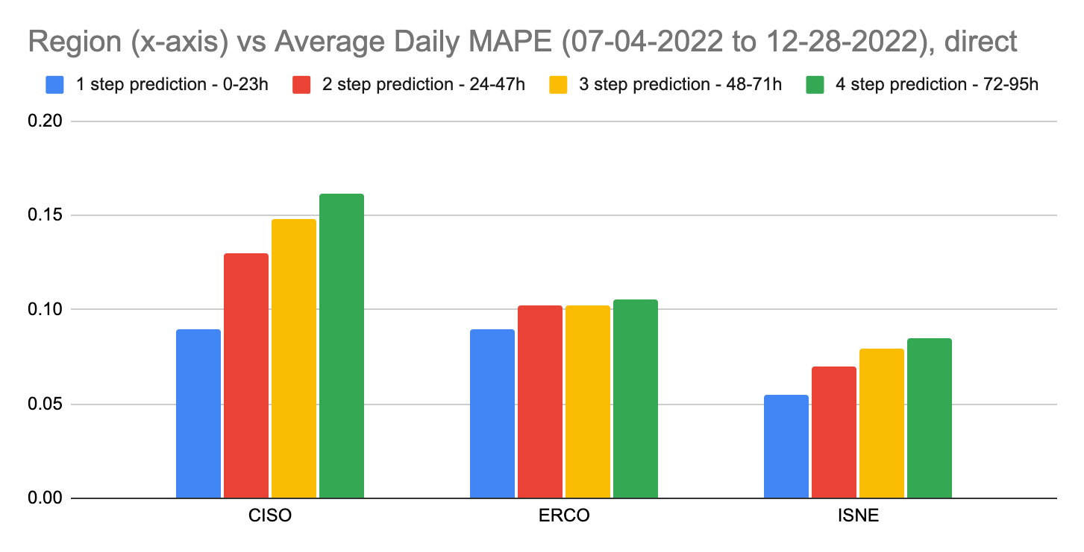
  + [CISO vs ERCO vs ISNE](https://docs.google.com/spreadsheets/d/1TlLBv7CuXGzDJeh7VhnGHBSpNWtAxclfr7SH4HpLafU/edit#gid=44947223) **Compare 1-4 step MAPEs**  tab

variance per hour - can also take and plot from any of the data

* eg. CISO - error in per hour predictions from 0h to 96h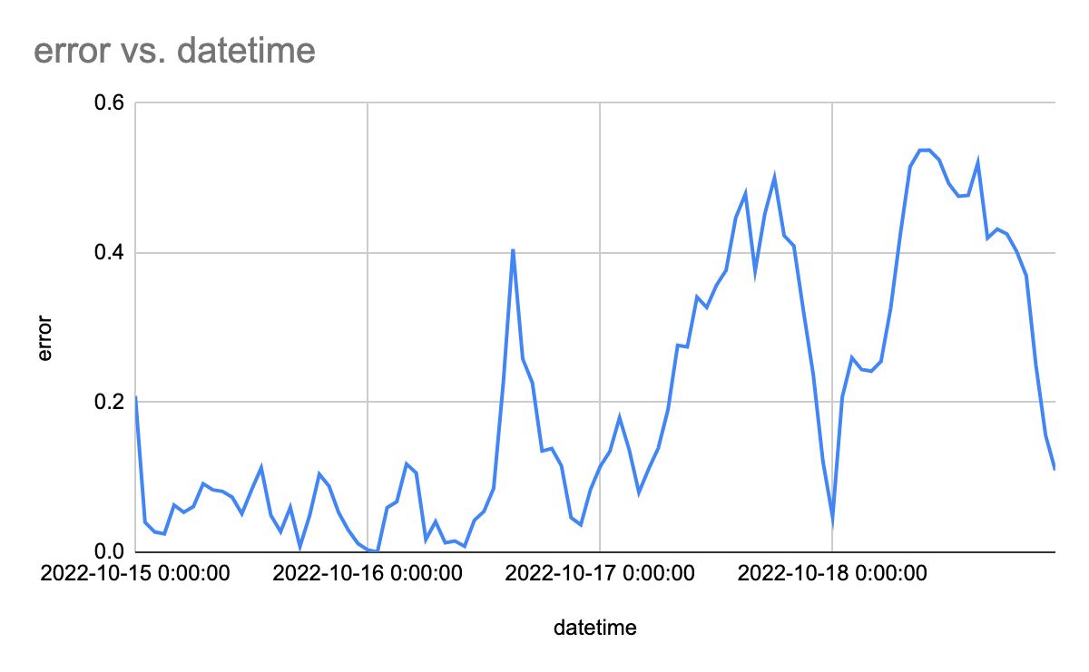
* look at [CISO](https://docs.google.com/spreadsheets/d/1mpgA3tr3FFkP71AMjAuAj32GnDb58WpNNFPaV-9KxYc/edit#gid=2112108709) **CISO direct - 1 to 4 day error** tab

### 4. Evaluation (Results with SPCI confidence intervals)

Used pretrained models - same ones as the ones we used in section 2^ to generate the motivation CC graphs

All raw csvs - [raw csvs - SPCI intervals with CarbonCast](https://drive.google.com/drive/u/0/folders/1SyD7xZY0UDVnirLAfSFrI6LgQC2d22xJ)

* true value, prediction, + SPCI confidence interval for CISO, ERCO, ISNE
  + 1 day ahead predictions (24h only)
  + alpha = 0.1 (90%), alpha = 0.05 (95%), alpha = 0.01 (99%) X direct, lifecycle
    - 6 csvs per region

coverage   
(test data of july 2 2022 - dec 28 2022)

| coverage  (test data of july 2 2022 - dec 28 2022)  QR based on last 2 weeks of data | alpha=0.1 (90%) | alpha=0.05 (95%) | alpha=0.01 (99%) |
| --- | --- | --- | --- |
| CISO - direct | 0.6555555555555556 | 0.7826388888888889 | 0.9217592592592593 |
| CISO - lifecycle | 0.6710648148148148 | 0.7976851851851852 | 0.91875 |
| ERCO - direct | 0.5965277777777778 | 0.6747685185185185 | 0.8182870370370371 |
| ERCO - lifecycle | 0.569212962962963 | 0.6543981481481481 | 0.8182870370370371 |
| ISNE - direct | 0.5273148148148148 | 0.6175925925925926 | 0.7516203703703703 |
| ISNE - lifecycle | 0.5592592592592592 | 0.6523148148148148 | 0.7944444444444444 |

Graphs to plot:

* look at sliding window size - right now QR predicts on past 2 weeks, look at shrinking that
* look at coverage % per month to see if there are any seasonal changes
* also could look at coverage % per hour to see if any specific hours perform worse
* try hourly predictions

CISO before (24h pred) vs after (hourly)

[alpha=0.1 CISO hourly vs 24h pred - 07-02-2022 to 07-11-2022](https://docs.google.com/spreadsheets/d/1YYlUCXnSgeqeHFlbkJSFXi9vBLCbedj4imybJCCvaEI/edit)

FINAL RESULTS - [raw csvs - SPCI intervals with CC (hourly pred)](https://drive.google.com/drive/u/0/folders/1UoSgw9TqmtJK1FOs25qvlqDeUrCmDHpi)

coverage   
(test data of july 2 2022 - dec 27 2022)

| coverage  (test data of july 2 2022 - dec 27 2022)  QR sliding window size = 24h  hourly predictions | alpha=0.1 (90%) | alpha=0.05 (95%) | alpha=0.01 (99%) |
| --- | --- | --- | --- |
| CISO - direct | Average Coverage is 0.9241154562383612  Average Width is 0.15175501983688244 | Average Coverage is 0.9634543761638734  Average Width is 0.19381614476394507 | Average Coverage is 0.9927839851024208  Average Width is 0.2896453120587029 |
| ERCO - direct | Average Coverage is 0.9201582867783985  Average Width is 0.1641151163695963 | Average Coverage is 0.960195530726257  Average Width is 0.20356009615531906 | Average Coverage is 0.9909217877094972  Average Width is 0.2853699158748958 |
| ISNE - direct | Average Coverage is 0.909217877094972  Average Width is 0.12807282925543026 | Average Coverage is 0.9574022346368715  Average Width is 0.1539765581557309 | Average Coverage is 0.9892923649906891  Average Width is 0.2090439154925216 |

takes ~40 min to generate 3

to plot

* 3 locations, over a week, 95%?
* table with all 9 coverage %s

[SPCI results.ipynb](https://colab.research.google.com/drive/1OC2n4lyWjXXJ9U_DPCHAeAitC6KJLrS-#scrollTo=2FA0gykobyc_)

